# Lab: Dictionaries, Lambda and LINQ

Problems for exercises and homework for the [“Programming Fundamentals” course @ SoftUni](https://softuni.bg/courses/programming-fundamentals).

Check your solutions here: <https://judge.softuni.bg/Contests/174/Dictionaries-Lambda-and-LINQ-Lab>.

# Associative Arrays

## Count Real Numbers

Read a **list of real numbers** and **print them in ascending order** along with their **number of occurrences**.

### Examples

|  |  |  |  |  |  |  |  |
| --- | --- | --- | --- | --- | --- | --- | --- |
| **Input** | **Output** |  | **Input** | **Output** |  | **Input** | **Output** |
| 8 2.5 2.5 8 2.5 | 2.5 -> 3 times  8 -> 2 times | 1.5 5 1.5 3 | 1.5 -> 2 times  3 -> 1 times  5 -> 1 times | -2 0.33 0.33 2 | -2 -> 1 times  0.33 -> 2 times  2 -> 1 times |

### Hints

* Use SortedDictionary<double, int> named counts.
* Pass through each input number num and increase counts[num] (when num exists in the dictionary) or assign counts[num] = 1 (when num does not exist in the dictionary).
* Pass through all numbers num in the dictionary (counts.Keys) and print the number num and its count of occurrences counts[num].

## Odd Occurrences

Write a program that extracts from a given sequence of words all elements that present in it **odd number of times** (case-insensitive).

* Words are given in a single line, space separated.
* Print the result elements in lowercase, in their order of appearance.

### Examples

|  |  |
| --- | --- |
| **Input** | **Output** |
| Java C# PHP PHP JAVA C java | java, c#, c |
| 3 5 5 hi pi HO Hi 5 ho 3 hi pi | 5, hi |
| a a A SQL xx a xx a A a XX c | a, SQL, xx, c |

### Hints

* Use a **dictionary** (string 🡪 int) to count the occurrences of each word (just like in the previous problem).
* Pass through all **key-value pairs** in the dictionary and append to the results list all **keys** that have **odd value**.
* Print the results list.

# LINQ

## Sum, Min, Max, Average

Write a program to read **n** integers and print their **sum**, **min**, **max**, **first**, **last** and **average** values.

### Examples

|  |  |
| --- | --- |
| **Input** | **Output** |
| **5**  12  20  -5  37  8 | Sum = 72  Min = -5  Max = 37  Average = 14.4 |
| **4**  50  20  25  40 | Sum = 135  Min = 20  Max = 50  Average = 33.75 |

### Hints

* Include the “System.Linq” namespace to enable aggregate functions.
* Read the input array nums[].
* Use nums.Min(), nums.Max(), etc.

## Largest 3 Numbers

Read a **list of real numbers** and **print largest 3 of them**. If less than 3 numbers exit, print all of them.

### Examples

|  |  |  |  |  |
| --- | --- | --- | --- | --- |
| **Input** | **Output** |  | **Input** | **Output** |
| 10 30 15 20 50 5 | 50 30 20 | 20 30 | 30 20 |

### Hints

You can use LINQ query like this: nums.OrderByDescending(x => x).Take(3).

## Short Words Sorted

Read a **text**, extract its **words**, find all **short words** (less than 5 characters) and print them **alphabetically**, in **lowercase**.

* Use the following separators: . , : ; ( ) [ ] " ' \ / ! ? *(space)*.
* Use case-insensitive matching.
* Remove duplicated words.

### Examples

|  |  |
| --- | --- |
| **Input** | **Output** |
| In SoftUni you can study Java, C#, PHP and JavaScript. JAVA and c# developers graduate in 2-3 years. Go in! | 2-3, and, c#, can, go, in, java, php, you |

### Hints

* To extract the words from the input text, **split** by the specified separators.
* Use a **LINQ expression**:
  + Filter by word length: Where(…)
  + Order by word: OrderBy(…)
  + Use **distinct** to avoid repeated words: Distinct().

## Fold and Sum

Read an array of **4*k integers**, **fold** it like shown below, and **print the sum** of the upper and lower rows (**2*k integers**):

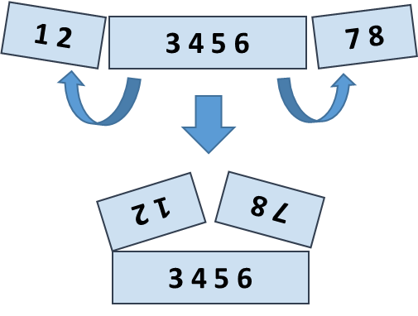

### Examples

|  |  |  |
| --- | --- | --- |
| **Input** | **Output** | **Comments** |
| 5 **2 3** 6 | 7 9 | 5 6 +  2 3 =  7 9 |
| 1 2 **3 4 5 6** 7 8 | 5 5 13 13 | 2 1 8 7 +  3 4 5 6 =  5 5 13 13 |
| 4 3 -1 **2 5 0 1 9 8** 6 7 -2 | 1 8 4 -1 16 14 | -1 3 4 -2 7 6 +  2 5 0 1 9 8 =  1 8 4 -1 16 14 |

Hints

Use a **LINQ expression**:

* Row 1, left part: take the **first** k numbers and **reverse**.
* Row 1, right part: **reverse** and take the **first** k numbers.
* **Concatenate** the **left** and the **right** part of row 1.
* Row 2: skip the **first k** numbers and take the next **2*k** numbers.
* Sum the arrays row1 and row2: var sum = row1.Select((x, index) => x + row2[index]).